Assignment 5
State
Alishba Azhar: 000925324
Thomas Coons: 000317961
Pouya Tayyari: 000949516
Khushal Parimal Valand: 000922744
Mohawk College
COMP-CO835-09: Object Oriented Systems
Dr. Stanley Ukah
November 7th, 2024

- What are State diagrams and what are they used for specifically?
According to the textbook, a state diagram is the visual representation of an object throughout its life cycle that shows the states and transitions that occur for that object (p. 116, John W. Satzinger et al).
State diagrams are used to model the dynamic behavior of objects, particularly within a specific class.
An example would be the different states between a stop light system.
- Pseudostart is the beginning of the stop light sequence.
- Each colour of the stop lights (green, yellow, red) represents the different states.
- The transitions between each state would be represented by a timer.
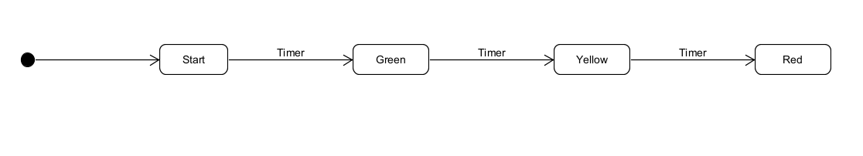
- How are State diagrams different from Class diagrams? Are they complimentary to Class diagrams or serve a totally different purpose?
Class diagrams show the static structure of a system (classes, attributes, relationships), while state diagrams show the dynamic behavior of an object (states and transitions). They are complementary: class diagrams provide structure, and state diagrams detail behavior.

- How are the different types of relationships represented in a State diagram?

- Transitions
- The primary relationship in state diagram is the transition, which shows movement from one state to another.
- Arrows joining two states are commonly used to symbolise transitions. They are frequently associated with the transition-triggering events, and occasionally with guards (conditions) and actions (outputs or changes brought about by the transition).
- Example: in the vending machine, the transition from the “waiting for selection” state to “Dispensing Item” state might be labeled by the event “Select Item.”
- Composite state (Nested states)
- A state can have substates (nested states) with their own transitions thanks to composite states. This simulates scenarios in which a system is active at several levels.
- Composite states are represented by enclosing substates within a large state boundary
- Example: In an online shopping process, a “checkout” composite states could include substates like “entering address”, “selecting payment” and “Reviewing Order”
- Parallel States (concurrent region)
- Concurrent processes that can happen on their own are represented by parallel states. They are frequently employed in systems that allow for the simultaneous execution of several actions.
- To illustrate these states, a composite state is divided into regions, each of which has its own set of states and transitions, and these areas are separated by dashed lines.
- Example: For a washing machine, a “Washing” state could contain concurrent region for “water fill” and “drum rotation”, which operate in parallel.
- Self-transition
- When a state needs to stay the same but carry out an activity, self-transitions—transitions that return a state to itself—are frequently employed.
- Represented by an arrow looping back to state itself.
- For instance: when a user repeatedly enters the wrong password in a login system, the system may self-transition into a "Locked" state, increasing an internal counter while remaining locked.
- Entry and exit points
- For composite states, entry and exit points stand for conditional entry and exit. They are frequently employed in more intricate models to illustrate prerequisites for entering or exiting a composite state.
- Small circles with arrows heading into and out of the composite state are known as entry and exit points, respectively.
- Example: For exceptional circumstances, a "Process Order" state in an order management system may have entry points to bypass specific processes (such as "Pending Payment").
- Guard condition
- Guards are condition that must be met for a transition to occur, typically shown as Boolean expression.
- They’re shown in square brackets on the transition arrow, next to the triggering event.
Example: In a payment processing state, a guard condition like “[Card Valid]” could restrict the transition from “Payment Initiated” to “Processing

- Draw a state diagram to illustrate the different states of PC usage in a computer lab at Mohawk College, from the time you turn it on at the beginning of a lab session until you shut it off. Two states per student in a team with your names attached to the two diagrams will be required for this question
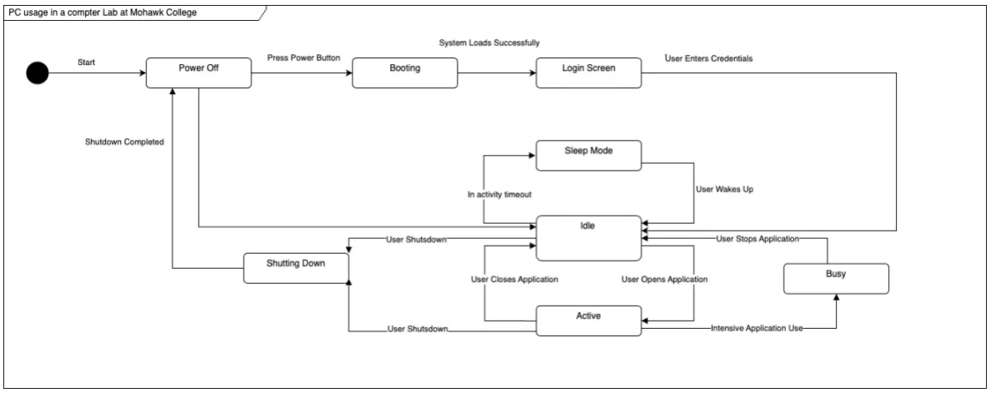

Power Off and Booting Thomas Coons
Login Screen and Sleep Mode Alishba Azhar
Idle and Active Khushal Parimal Valand
Shutting Down and Busy Pouya Tayyari

References
Satzinger, J. W., Jackson, R. B., & Burd, S. D. (2016). Systems analysis and design in a changing world
(7th ed.). Cengage Learning.

